Guided Tutorial for Pentaho Data Integration using PostgreSQL

In the data integration exercise, you will use the Pentaho Data Integration tool to transform two data sources and load data into a PostgreSQL fact table. You will perform transformations to parse date strings, combine fields, and perform validation checks. Before starting this tutorial, you need to install necessary software, download data sources, and create tables used in the tutorial.

# 1. Tutorial Prerequisites

Before starting this tutorial, you should download and install the server and client for MySQL. You can find details in Module 1 about PostgreSQL installation. If you have access to a remote PostgreSQL server (perhaps through your employer), you do not need to install the server software on your own machine.

You also need to install Pentaho Data Integration before starting this tutorial. Module 1 contains installation instructions about Pentaho Data Integration. This tutorial demonstrates the community edition of the most recent version (9.0) of Pentaho Data Integration as of April 2020. Pentaho Data Integration 9.0 installs with a PostgreSQL database driver so no driver installation is necessary.

After installing Pentaho Data Integration, you need to obtain the data sources used in the tutorial from the class website.

* Excel file used in part 1 of the tutorial
* Access database used in part 2 of the tutorial

The tutorial uses the Store Sales data warehouse as depicted in Figure 1. Sales is the fact entity type surrounded by 1-M relationships with dimension entity types, Item, Customer, Store, and TimeDim. The schema design has a snowflake for the 1-M relationship from Division to Store. In the table design, table names have been preceded with the prefix “SS” to avoid conflicts with other tables. Thus, the fact table is *SSSales*, not Sales as shown in the ERD of Figure 1.

The course website contains documents with SQL statements to create and populate tables for Oracle, MySQL, and PostgreSQL. For this exercise, you need to create and populate the tables using the documents for PostgreSQL. The PostgreSQL document also contain statements to create sequence objects for the *SSTimeDim* and *SSSales* tables.

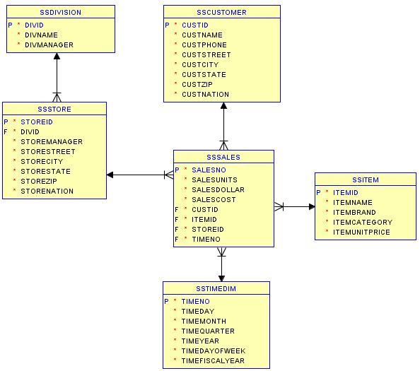

Figure 1: Oracle Snowflake Schema for the Store Sales Data Warehouse

Figure 1: Pentaho Data Integration Welcome Window

To install Pentaho, you should follow the steps below. It is highly recommended that you use the community edition from SourceForge as the instructions in this document follow the community edition interface.

* The latest stable version is 5.0.1 although the latest version on SourceForge is 9.0.0. You should be able to use either version to complete the tutorial and assignment although the guided tutorial is written for the latest version 9.0.0.
* To use a different version (such as the latest stable version), go to <http://sourceforge.net/projects/pentaho/> and search in the Files link. To find a different version, look in the Client-Tools folder of the version of interest. You should select the link with PDI in the name inn the Client-Tools folder such as pdi-ce-8.2.0.0-371.zip.
* Unzip the downloaded zip file to any folder.
* Windows users should copy the folder data-integration to the folder C:\Program Files\Pentaho. Mac and Linux users may move the file to any folder.

To ensure that the installation worked, you should launch Pentaho Data Integration.

* Run the file Spoon.bat by double clicking on it. You may want to create a shortcut to the spoon.bat file so starting data integration is easier. If you get a permission error or cannot execute the bat file, you should right click and select “Run as Administrator”. For Mac and Linux users, run the Spoon.sh from terminal (./spoon.sh).
* After you launch Pentaho Data Integration, you will see the Welcome window (Figure 1) and then the Spoon designer (Figure 2).
* Exit Spoon before installing the database driver file in the next part of the instructions.

After you launch Pentaho Data Integration, the Spoon designer is launched at the same time (Figure 2). *Spoon* provides a graphical interface that supports creation of transformations (data flows) and jobs (execution sequences) as well as execution and testing of Pentaho Data Integration processes. Spoon builds jobs and transformations and can save them as database repository and files.

# 2. Creating your first transformation

The Data Integration component of Spoon allows you to create two basic document types: transformations and jobs. Transformations are used to describe data flows such as reading from a source, transforming data and loading it into a target location. Jobs are used to coordinate data integration activities such as defining the flow and dependencies for what order transformations should be run, or prepare for execution by checking conditions such as, “Is my source file available?” or “Does a table exist in my database?

This exercise will step you through building your first transformation with Pentaho Data Integration introducing common concepts along the way.

Follow the instructions below to create a new transformation.

1. After starting Pentaho Data Integration, you will see the opening window (Figure 1) and the Spoon window (Figure 2).

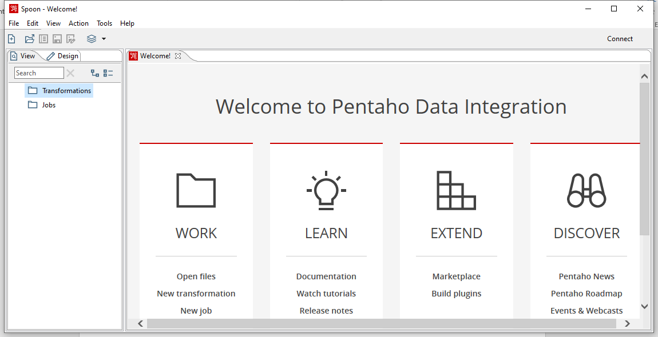

Figure 2: Spoon Opening Window

2. Click  (New File) in the upper left corner of the Spoon window.

3. Select **Transformation** from the list of components (Figure 3) displayed after selecting the **New File** button.

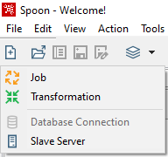

Figure 3: Spoon New File List

# 3. Load the first data source from Excel

Make sure that you have downloaded the Excel input file from the class website. You need to know the location of this file in Step 4 below.

Step 1 – In the View tab, right click the new transformation 1 and select “settings…”

Step 2 – Set the Transformation name for the new transformation as: SSTORETEST and click OK.

Step 3 – Save the transformation following **File → Save.** You will see the empty transformation window in the Spoon (Figure 4).

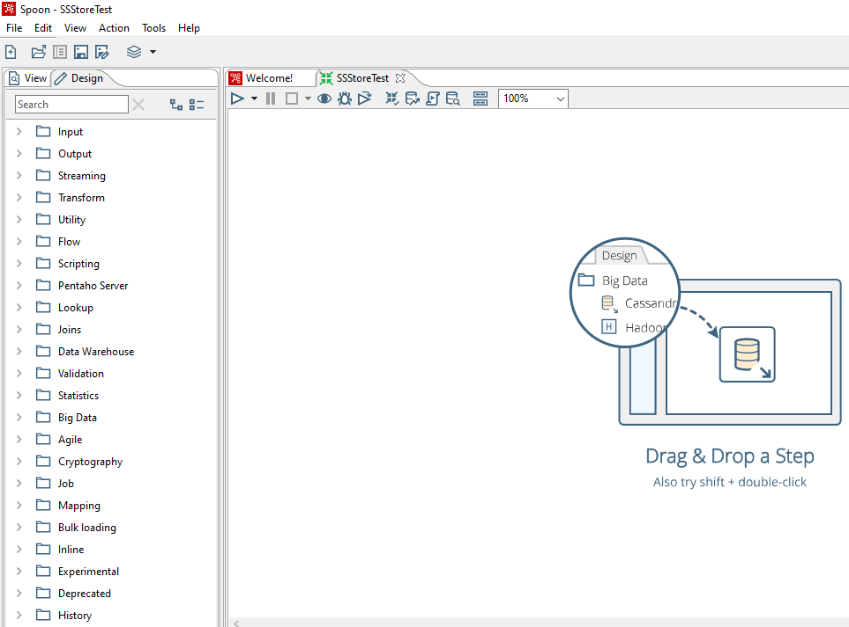

Figure 4: Empty Transformation Window

Step 4 – Create the Excel Input step:

* Under the Design tab, expand the Input step (Figure 5).

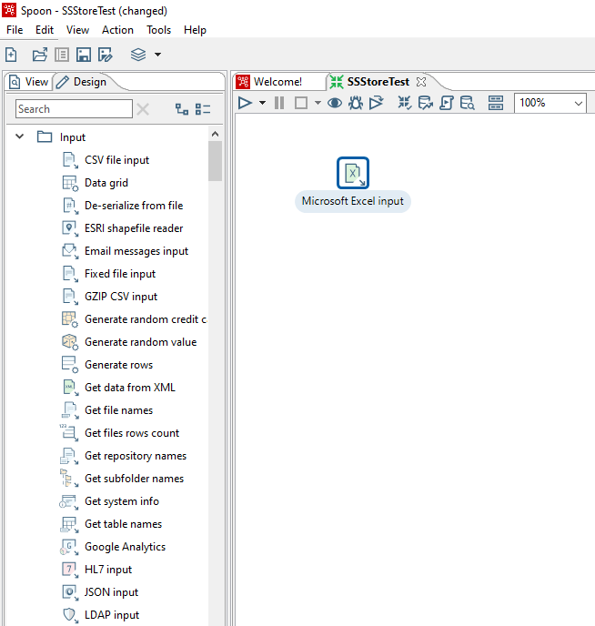

Figure 5: List of Input Steps with Microsoft Excel Input step in the Transformation Design Window

* Select and drag a **Microsoft Excel Input** step into the canvas on the right.
* Double Click on the **Microsoft Excel Input** step. The edit properties dialog box (Figure 6) associated with the **Microsoft Excel Input** step appears. In this dialog box, you specify the properties related to a particular step.

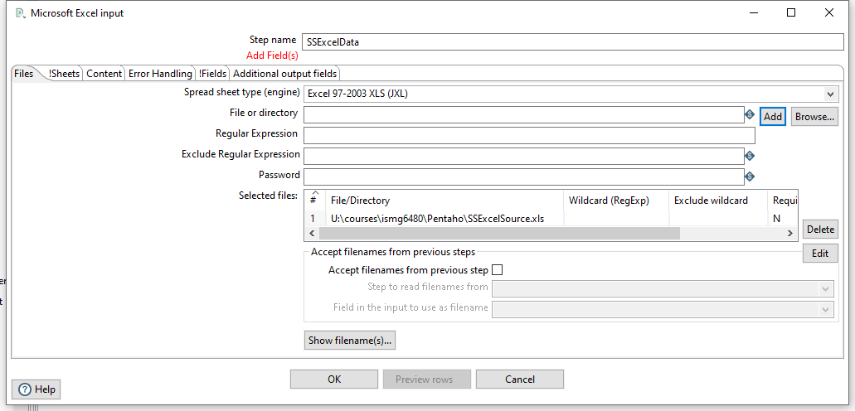

Figure 6: Files Window for Microsoft Excel Input Property Editing

* Set name for the Excel Input as **SSExcelData** and specify the Excel data source path in the **Files** tab.
* In the tab named **Files**, click the button “Browse…” and locate the Excel file that you downloaded from the class website. Then, Click “Add” to add the file to the selected files area.
* In the tab named **Sheets**, click the button “**Get sheetname(s)…**”. There will appear an **Enter List** (Figure 7) to choose sheets. Select **Sheet 1**, press “**>**” to move it into the right area. Click **OK**.
* In the tab names **Fields,** click on **“Get fields from header row…”** You need to change the data types, length, and precision as the specification in Figure 8.

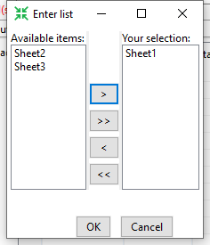

Figure 7: Sheet Specification Window

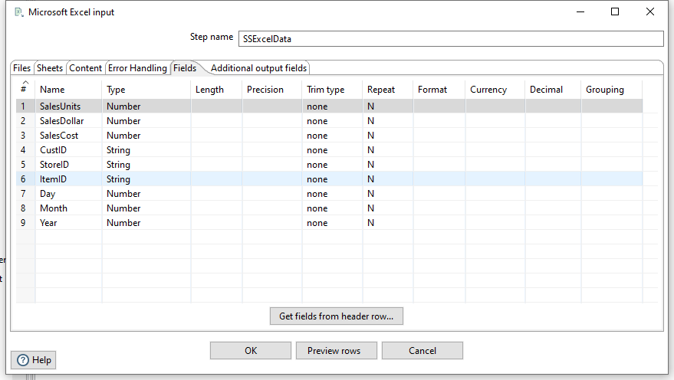

Figure 8: Fields Window for Microsoft Excel Input Property Editing

* Click **OK** at the bottom of the window. The input icon will change to the icon displayed in Figure 9.

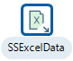

Figure 9: SSExcelData Icon

Step 5 – In this part of the tutorial, you will add constraint checking for null values in stream records obtained from the Excel data source. The rows from the Excel data source were added to the stream (data maintained in a Pentaho transformation) in the output of the first step.

* Add a Filter Rows step to your transformation. Under the **Design** table, go to **Flow** → **Filter Rows** (Figure 10).

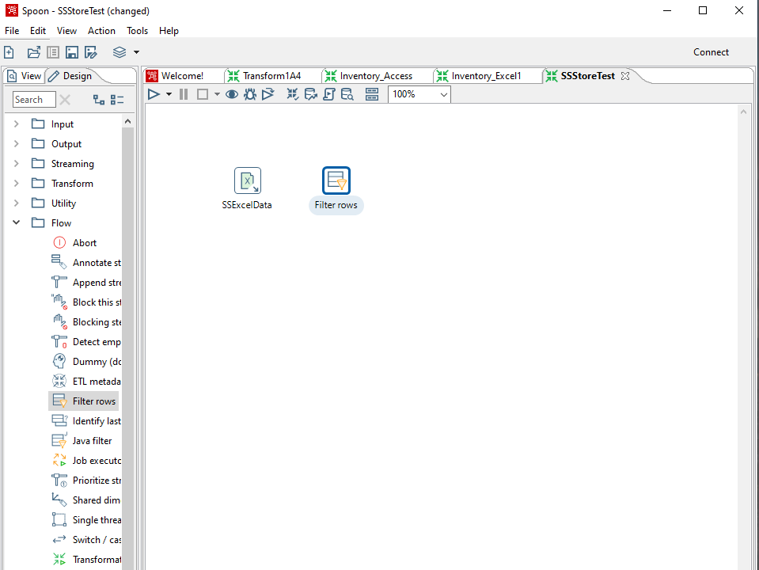

Figure 10: Excel Input Step and Filter Rows Step in Transformation Design Window

* Create a “hop” between the **SSExcelSource** (Excel file input) step and the **Filter Rows** step. Hops are used to describe the flow of data in your transformation. To create the hop, click the **SSExcel Source** (Excel file input) step, then press the <**SHIFT**> key down and draw a line to the Filter Rows step (Figure 11).

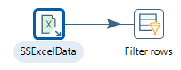

Figure 11: Hop connecting an Excel Input Step Connected to a Filter Rows Step

* Alternatively, you can draw hops by hovering over a step until the hover menu (Figure 12) appears. Drag the hop painter icon from the source step to your target step.

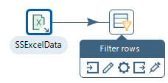

Figure 12: Hover Menu

* Double-click the **Filter Rows** step. The **Filter Rows** edit properties dialog box appears (Figure 13).

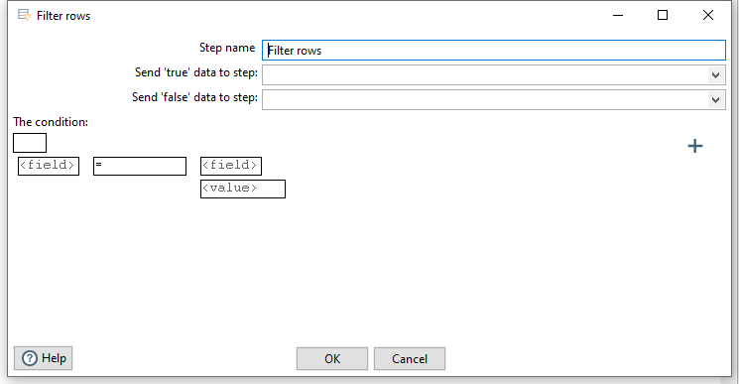

Figure 13: Property Edit Window of Filter Step

* The **Step Name** field is **Filter rows**.
* Under **The condition**, click <field>. A dialog box that contains the fields you can use to create your condition appears.
* In the **Fields**: dialog box (Figure 14) select **SalesUnits** and click **OK**.

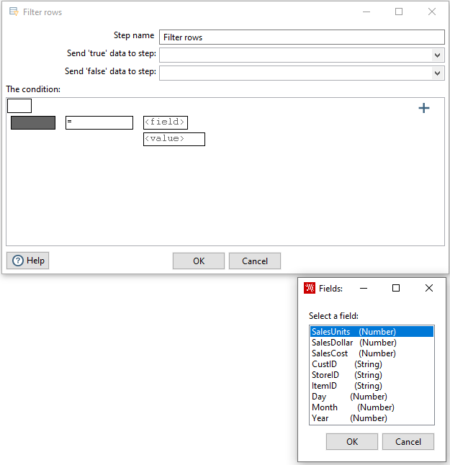

Figure 14: Condition Fields Selection Window

* Click on the comparison operator (Figure 15) (set to = by default) and select the **IS NOT NULL** function and click **OK**.

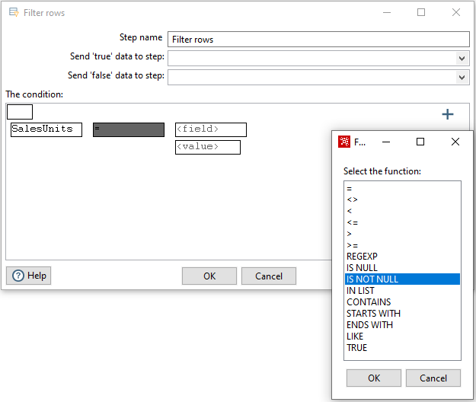

Figure 15: Comparison Operator List

* Click the button . A new condition row appears with **null = [ ]** as a default.
* Click on the expression and add constraints for the next column similarly to what you did for “**SalesUnits**”
* Click on **UP**. This will allow you to see both conditions connected by AND.
* Click the button again. Another new condition row appears with **null = [ ]** as a default.
* Keeping repeating these steps for all fields.
* The final view of filter conditions is shown by Figure 16.

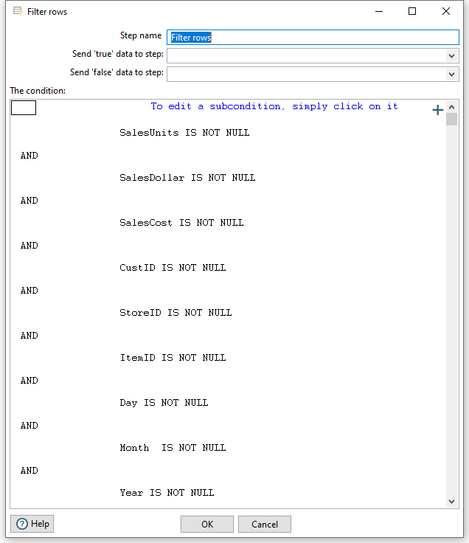

Figure 16: Filter Conditions Window

* Save your transformation.

Step 6 – Create a step to sort the result of the Filter Rows step.

* Under the **Design** tab, expand the contents of the **Transform** step.
* Click and drag a **Sort Rows** step into your transformation; create a hop between the **Filter rows** and Sort Rows steps. Select **Result is TRUE** in the filter results selection list (Figure 17).

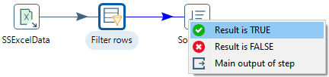

Figure 17: Filter Results Selection List

* Double-click the **Sort Rows** step to open its edit properties dialog box (Figure 18). Click “**Get Fields**” to obtain the fields. Delete other fields except the Day, Month and Year fields. Then click Ok.

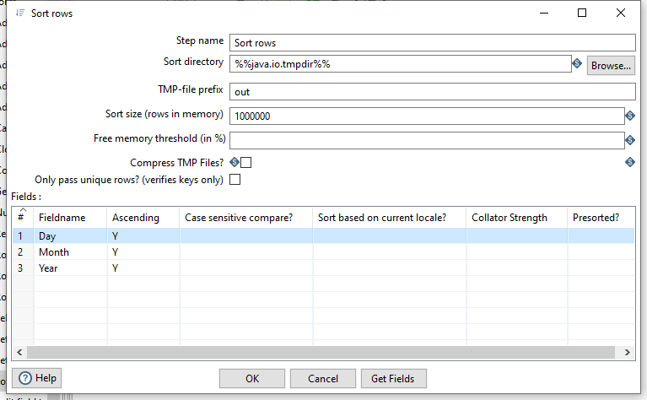

Figure 18: Property Edit Window of Sort Rows Step

# 4. Using a Database Connection to Lookup Columns from PostgreSQL tables

Pentaho Data Integration allows you to define connections to multiple databases provided by multiple database vendors (MySQL, Oracle, Postgres, and many more). Pentaho Data Integration ships with the most suitable JDBC drivers for supported databases and its primary interface to databases is through JDBC. Vendors write a driver that matches the JDBC specification and Pentaho Data Integration uses the driver. Unless you require extensive debugging or have other needs, you will not ever need to write your own database driver.

When you define a database connection, the connection information (username, password, port number, and so on) is stored in the Pentaho Enterprise Repository and is available to other users when they connect to the repository. If you are not using the Pentaho Enterprise Repository, the database connection information is stored in the XML file associated with a transformation or job.

Connections that are available for use with a transformation or job are listed under Database **Connection** node in the explorer **View** in Spoon.

There are several ways to define a new database connection:

* In Spoon, under View in the navigation tap, right click Database connections and choose New.
* In Spoon, under View in the navigation tap, right click Database connections and choose New Connection Wizard.
* In the Table input configuration box, click on New.

This part of the tutorial involves looking up the date from the *SSTimeDim* table to check the validity of dates in the Excel data source. In addition, you will lookup primary key columns from other PostgreSQL tables to ensure loaded data does not contain invalid foreign keys.

Step 1 – Access the *SSTimeDim* table from PostgreSQL database.

* Under the **Design** tab, expand the contents of the **Input** step.
* Click and drag a **Table Input** step into your transformation.
* Double-click the Table Input step to open its edit properties dialog box (Figure 19).
* Rename your Table Input step to *SSTimeDim*.

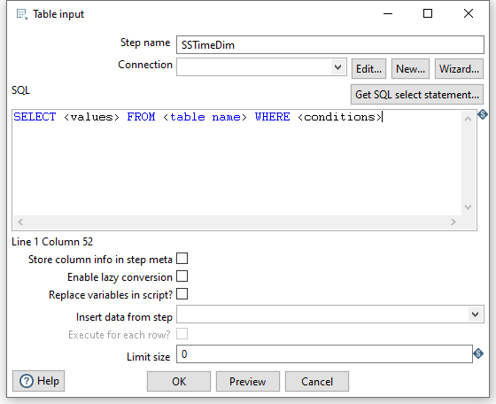

Figure 19: Property Edit Window of Table Input Step

* Click “**New…**” next to the connection field. You must create a connection to the database. The Database connection dialog box appears.
* Provide the settings for connecting to the database as shown in Figure 20. You can choose any name for the connection.
* **IMPORTANT**: Before setting the connection information, you should ensure that the database is created in PostgreSQL along with the tables and the records inserted into those tables. Here are the details to connect to the PostgreSQL 12.2. The Database Name and the Username are the one that you created in PostgreSQL. The full values for database connection components is given below.

Figure 20: Database Connection Window

* Connection Name: PostgreSQL12.2 (You can use another name if you want)

Connection Type: PostgreSQL

Host Name: localhost

Database Name: StoreSales (unless you used a different name)

Port Number: 5432

Username: postgres (default administrative user name)

Password: <blank> (if password was not specified or use password specified.)s

Access: Native (JDBC)

Note: The username “postgres” is the default administrative user after installation of PostgreSQL. For the password, you need to use the password that you specified if any. In this example, the password for the postgres user was omitted during PostgreSQL installation. The Host Name and port number are the default values for Windows 10 installation of PostgreSQL.

* Click “Test” to test the connection. Then success test result is shown by Figure 21.

Figure 21: Database Connection Test

* Type in “SELECT * FROM SSTimeDim” in the SQL section (Figure 22). You can click the **Preview** button to view the database. Click Ok, to exit the Database Connection dialog box.

Figure 22: SQL Edit Section in Property Window of Table Input Step

* Add another sort rows component **Sort rows 2**, and a hop connecting the *SSTimeDim* step. In the field specification (Figure 23), delete other fields except TIMEDAY, TIMEMOHTH, TIMEYEAR fields.

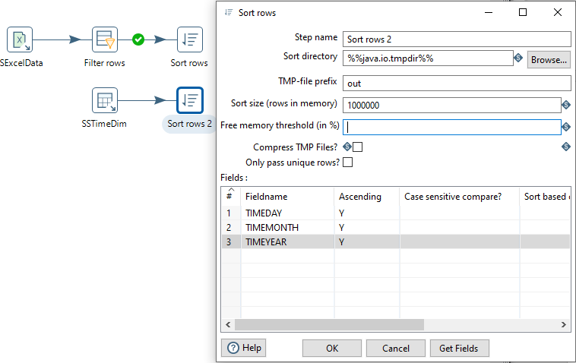

Figure 23: Property Edit Window of Sort Rows 2 Step

* Under the **Design** tab, expand the contents of the **Joins** step.
* Click and drag a **Merge Join** step into your transformation; create a hop between the **Sort rows, Sort rows 2** and **Merge Join** steps (Figure 24).

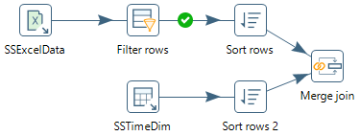

Figure 24: Two Sort Rows Steps Connected to Merge Join Step

* Double-click the Merge Join step to specify its properties (Figure 25). Set **First step** as **Sort rows**, **Second step** as **Sort rows 2**, and **Join Type** as **INNER**. Click both of the “**Get key fields**” at left and right to get the possible fields to join. In the left table, delete other fields except Day, Month and Year fields. In the right table, delete other fields except *TIMEDAY*, *TIMEMONTH*, and *TIMEYEAR* fields. Then click OK.

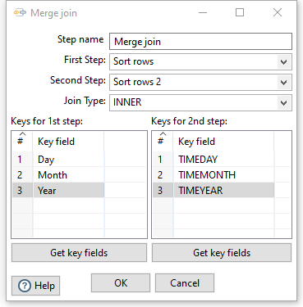

Figure 25: Property Edit Window of Merge Join Step

* Now, we have finished inner join between Excel input and *SSTimeDim* table.

Step 2 – Inner join the *SSItem*, *SSCustomer*, and *SSStore* tables.

Like getting data from the *SSTimeDim* table in the previous section, inner joining these tables requires **Table Input** components. First, you shoulld set the connection and SELECT statement for the *SSItem* table. Note that these tables should exist in your PostgreSQL schema before these steps.

* Drag and drop the **Table Input 2** into the design pane.
* Double click on the newly created component to open its Basic Settings pane. Specify the connection as shown in previous figure.
* Use “SSItem” as the Table Name value and “SELECT * FROM SSItem” as the Query value.
* Create two **sort rows** components: **Sort rows 3** and **Sort rows 4**, connecting **Merge Join** and **SSItem** respectively. See the field to be sorted as: **ItemID** and **ITEMID** respectively.
* Drag and drop the **Merge Join 2** into the design pane. Connect **Sort rows 3** and **Sort rows 4** to **Merge Join 2**. Set the field to be joined as **ItemID** and **ITEMID**.
* Figure 26 shows all steps and hops to the Merge join 2 step.

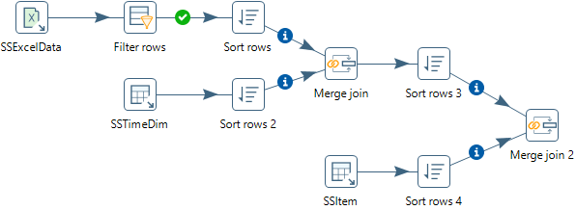

Figure 26: Transformation Design Showing Steps and Hops to the Merge Join 2 Step

Step 3 – Inner join the tables.

* Inner join the tables named *SSCustomer* and *SSStore* in your transformation using the same method described previously.
* For the *SSCustomer* step, connect the *CustID* (from Excel file) and CUSTID (from Database) fields.
* For the SSStore step, connect the *StoreID* (from Excel file) and STOREID (from Database) fields.
* Figure 27 shows all steps and hops after the Merge join 4 step.

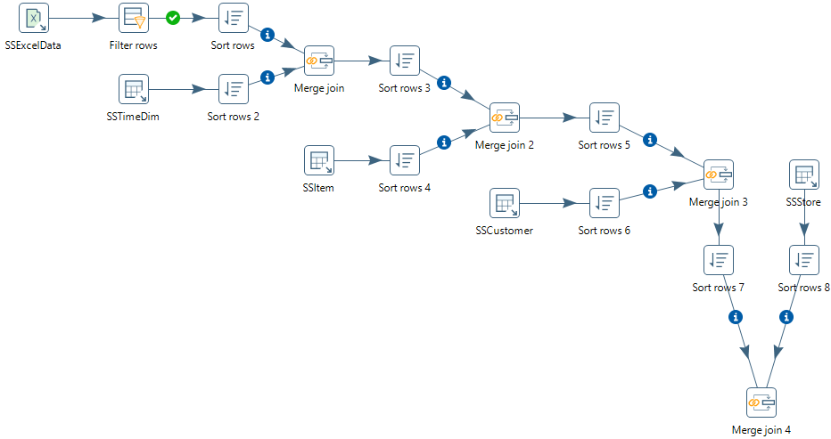

Figure 27: Transformation Design Showing Steps and Hops after the Merge Join 4 Step

Step 4 – Create and connect an Add Sequence step to generate values for the *SalesNo* column.

* Under the **Design** tab, expand the contents of the **Transform** step.
* Click and drag an **Add sequence** step into your transformation; create a hop between the **Merge Join 4** and **Add Sequence** steps (Figure 28). To create the hop, click the **Merge Join 4** step, then hold the <**SHIFT**> key down and draw a line to the **Add Sequence** step.
* Double click on the newly created component to open its Basic Settings pane.
* Set **SalesNo** as the name of value. Check the box for use DB to get sequence. Select the **connection** as **PostgreSQL12.2.** Set **SSSalesNoSeq** as sequence name (Figure 29).

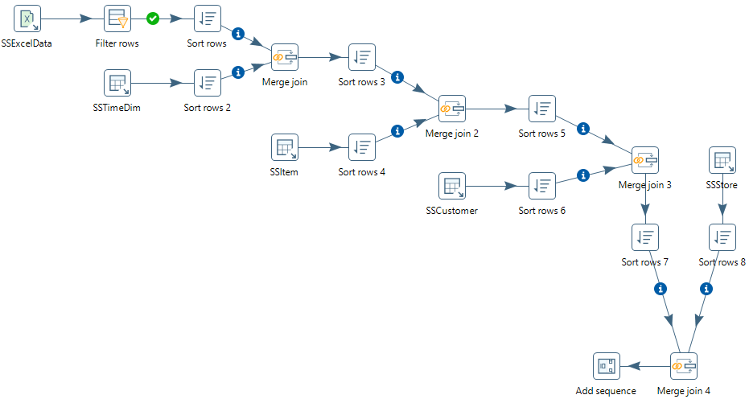

Figure 28: Transformation Design Showing Steps and Hops after the Add Sequence Step

Figure 29: Property Edit Window of Add sequence Step

# 5. Insert data into the SSSales table

* Under the **Design** tab, expand the contents of the **Output** step.
* Click and drag an **Insert/Update** step into your transformation; create a hop between the **Add sequence** and **Insert/Update** steps. Figure 30 shows the Insert/Update step (**SSSales**) connected to Add sequence step.

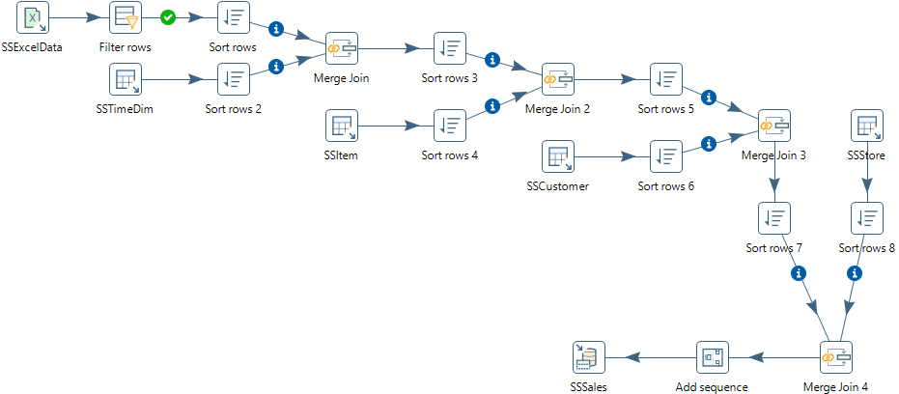

Figure 30: Connect Insert/Update Step to the Add Sequence Step

* Double click the **Insert/Update** step, to specify its properties (Figure 31). Set the **step name** as **SSSales**. Select the **connection** as **PostgreSQL12.2**. Type in the **Target table** as **SSSales** or click the **Browse** button and select the table from the list. Do not click the “**Get fields**” button. Instead, select SalesNo from the two sources and set the comparator to **=**. The final window should look like Figure 31.

Figure 31: Property Edit Window of Insert/Update Step

* Click the button “**Get Updated fields**” and then click on “**Edit mapping**” button to edit mapping. The mapping edit window is shown in Figure 32. Select the fields named **SalesUnits**, **SalesDollar**, **SaleCost**, **CustID,** **StoreID**, **ItemID** **TIMENO** and **SalesNo** into the **mappings** field. Pentaho will automatically match the corresponding name in the Target field. You may need to choose **SalesNo** stream field has matched with **SALESNO** column. Then click **OK**.

Figure 32: Mapping Edit Window

* Check the button “Don’t perform any updates:”. The final view of the **SSSales** step will look like Figure 33.

Figure 33: Final view of the SSSales step

* Select the **SSSales** step and run a preview by clicking on . In the transformation debug dialog, click on **Quick Launch** (Figure 34).

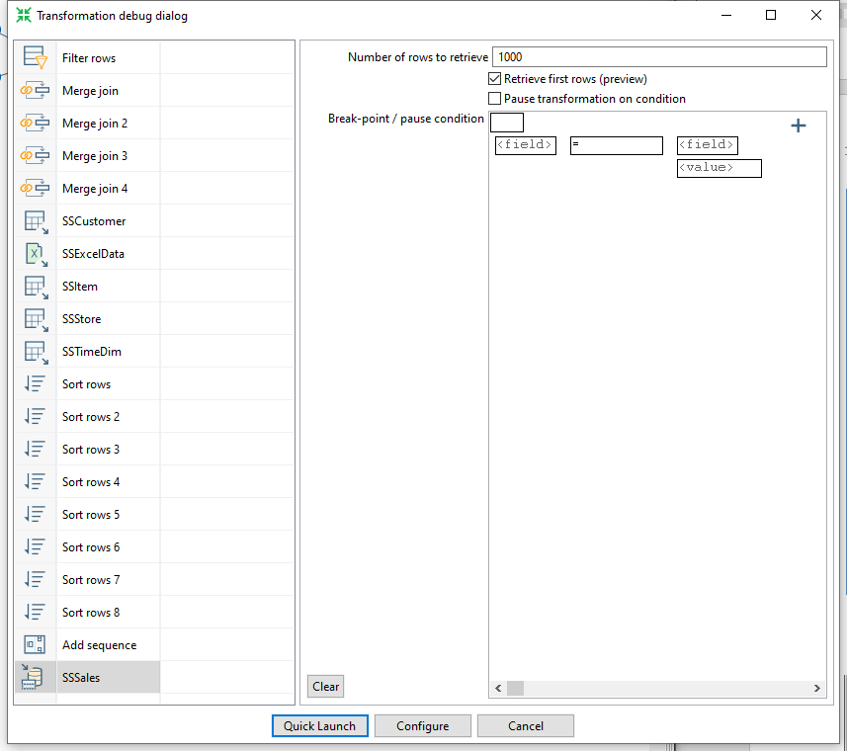

Figure 34: Transformation Debug Dialog

* The Examine preview data window is displayed in Figure 35.

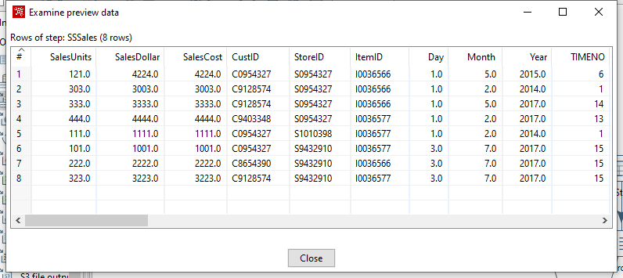

Figure 35: Examine Preview Data Window

* To examine the details of each step, you should examine the Execution Results window below the design pane. The Step Metrics tab (Figure 36) shows details about the execution of each step. You should verify that the **SSSales** step has 8 output rows.

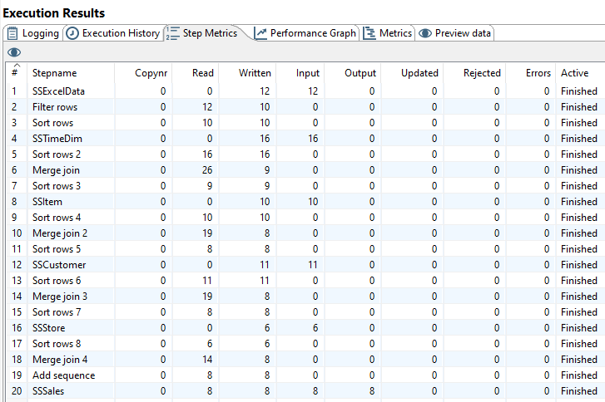

Figure 36: Step Metrics in the Execution Result Window

* Each step in the transformation should have a check mark indicating execution as shown in Figure 37.
* Connect to your PostgreSQL account (on your PC) so you can verify the number of rows in the *SSSales* table. You should see 200 rows with 8 new rows added to the 192 rows in the PostgreSQL *SSSales* table.
* If you do not see the extra rows, the PostgreSQL output component had a failure. To see the error, check the Logging and Step Metrics tabs of the **Execution Results** window.

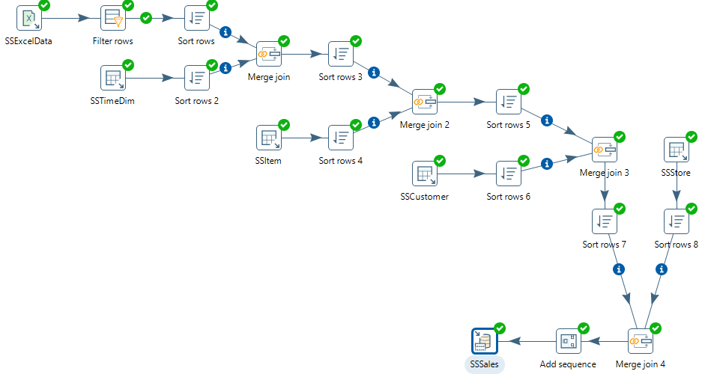

Figure 37: Transformation Design with Check Marks for Each Step

# 6. Load second data source from Access

The next part of the exercise involves creation of a new transformation to process the Access data source. Make sure that you have downloaded the Access database file from the class website and noted its location on your computer. Create a new transformation using **File → New → Transformation** with name “SSStoreTestAccess”. Use **File** **→** **Save As …** to save the transformation file as “SSStoreTestAccess” to a folder of your choice. Then, you will begin by loading the rows from a table in the Access database.

Step 1- Add the Access Input Step

* Under the Design tab, expand the Input step. Figure 38 shows the Design table and input step.

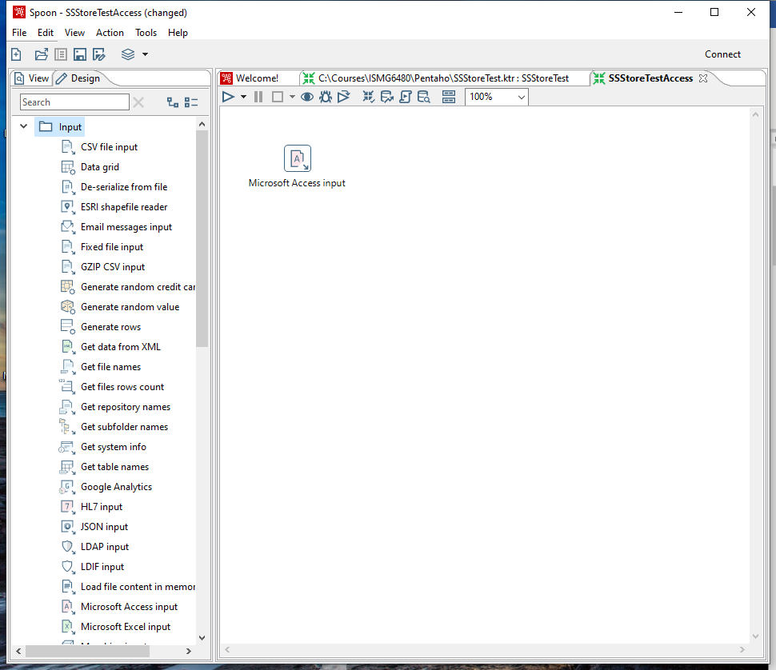

Figure 38: New Microsoft Access Input Step

* Select and drag a **Microsoft Access Input** step onto the canvas on the right.
* Double Click on the **Microsoft Access Input**. The edit properties dialog box associated with the **Microsoft Access Input** step appears (Figure 39). In this dialog box, you specify the properties related to this step.

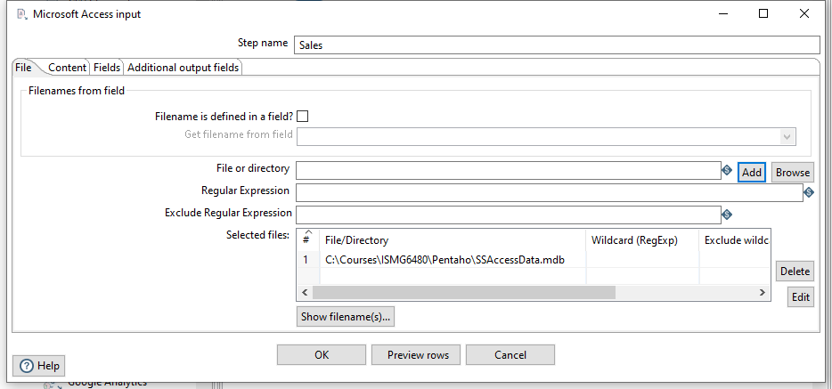

Figure 39: Property Edit Window of Microsoft Access Input Step

* Set name for the Access Input as **Sales** and specify the Excel data source path in the **Files** tab.
* In the tab named **Content**, click the button “**Get tables**” of **table** section. There will appear a window (Figure 40). Select **Sales** as the table name, click **OK**.

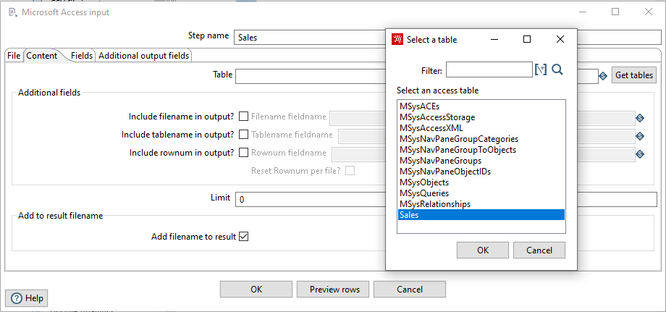

Figure 40: Table Selection Window

* In the tab named **Fields**, click the button “**Get fields**”. There will appear a list (Figure 41) showing the fields in the table named **Sales**.

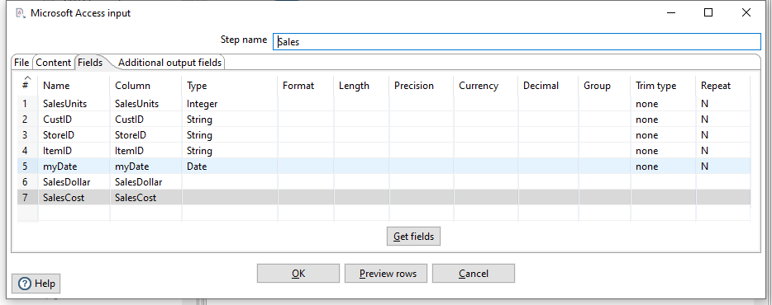

Figure 41: Fields Window for Microsoft Access Input Property Editing

* Click the button “**Preview rows**” to preview the database (Figure 42). When asked for the number of rows type 12 and click OK.



Figure 42: Examine Preview Data Window

* Click **OK** at the bottom of the window. The input icon will change to the shape shown by Figure 43.



Figure 43: Sales Step Icon

Step 2 –You will add constraint checking for null values using the Filter Rows step.

* Add a Filter Rows step to your transformation. Under the **Design** table, go to **Flow** → **Filter Rows**.
* Create a hop between the **Sales** (Access file input) step and the **Filter Rows** step. Hops are used to describe the flow of data in your transformation. To create the hop, click the **Sales** (Access file input) step, then press the <**SHIFT**> key down and draw a line to the Filter Rows step. The hop should be the main output of the **Sales** step. Figure 44 shows the transformation window after adding the new step and hop.

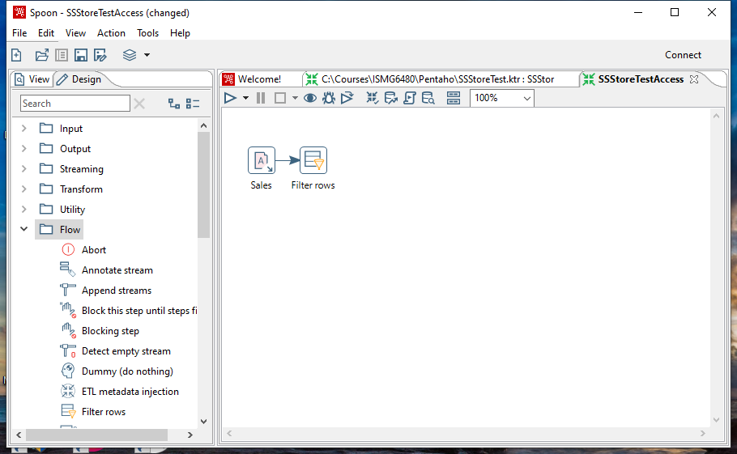

Figure 44: Access Input Step and Filter Step in Spoon

* Alternatively, you can draw hops by hovering over a step until the hover menu appears. Drag the hop painter icon from the source step to your target step.
* Double-click the **Filter Rows** step. The **Filter Rows** edit properties dialog box appears.
* In the **Step Name** field type, **Filter rows**.
* The configuration of this step is like the previous Excel transformation.
* The final view of filter conditions is shown in Figure 45. Save the transformation before adding new steps.

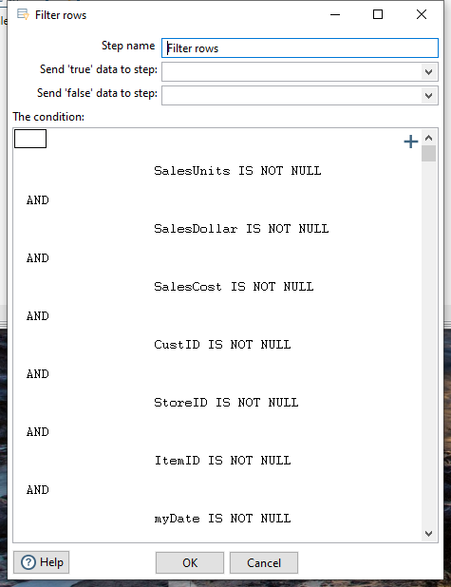

Figure 45: Filter Conditions Window

# 7. Separate SalesDay fields into Day, Month, Year fields

In this part of the tutorial, you will use the Select Values step to change the format of the myDate field and the Split Fields step to parse the field into date components.

* Under the **Design** tab, expand the contents of the **Transform** step.
* Click and drag a **Select values** step into your transformation.
* Create a “hop” between the **Filter rows** step and the **Select values** step (Figure 46). Select **Result is TRUE** in the filter results selection list



Figure 46: True Filter Results Connected to Select Values Step

* Double-click the Select values step to open its edit properties dialog box.
* In the tab named Meta-data, click the button “**Get fields to change**”, to get the fields to change, which is shown by Figure 47. Change the **Type** of field **myDate** as **String**, change its **Format** to dd-MM-yyyy. Click **OK**.

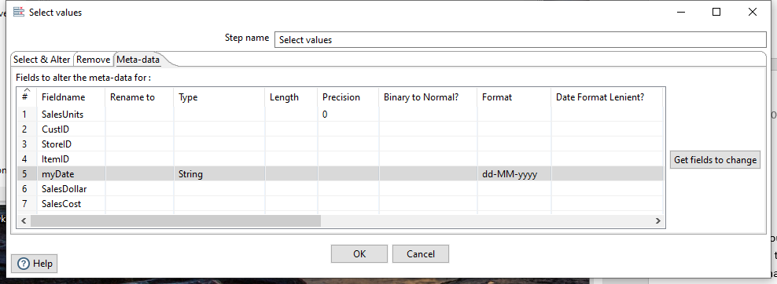

Figure 47: Meta-data Tab of Select Values Property Edit Window

* Under the **Design** tab, expand the contents of the **Transform** step.
* Click and drag a **Split fields** step into your transformation (Figure 48).
* Create a “hop” between the **Select values** step and the **Split fields** step. The hop should be the main output of the previous step.



Figure 48: Create Split Fields with Hop between Steps

* Double-click the **Split fields** step to open its edit properties dialog box (Figure 49).
* Select **myDate** in the **Field to split**, type “**-**” as the **Delimiter**. Type in **Year, Month** and **Day** in the Column named **New field**, and set their **Type** as **Number**. Click Ok when finished.

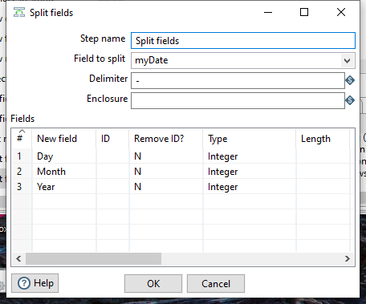

Figure 49: Property Edit Window of Field Splitter Step

* Select the Split fields step in the canvas and click  , to preview this transform (Figure 50). Make sure that Split Fields step is selected from the left side panel of the transformation debug dialog and click on “**Quick Launch**” button.

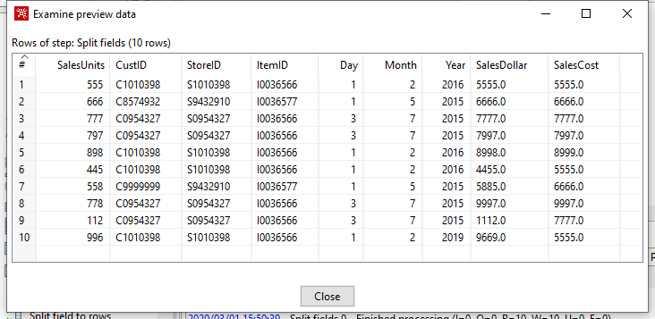

Figure 50: Examine Preview Data Window

# 8. Lookup Columns from the PostgreSQL tables

This part of the exercise involves looking up the date from the *SSTimeDim* table to check the validity of dates in the Access data source. In addition, you will lookup primary key columns from other PostgreSQL tables to ensure loaded data does not contain invalid foreign keys. This part of the exercise is similar to Section 3.

Step 1 – Access the *SSTimeDim* table from PostgreSQL database.

* Under the **Design** tab, expand the contents of the **Input** step.
* Click and drag a **Table Input** step into your transformation.
* Double-click the Table Input step to open its edit properties dialog box.
* Rename your Table Input step to *SSTimeDim*.
* For the Connection field, select PostgreSQL12.2 if it is available in the connection list. Otherwise, click “**New**” next to the connection field. Provide the settings for connecting to the database as shown in the Figure 20. Provide the settings for connecting to the database as shown in the Figure 20.
* Connection Name: PostgreSQL12.2 (You can use another name if you want)

Connection Type: PostgreSQL

Host Name: localhost

Database Name: StoreSales (unless you used a different name in PostgreSQL)

Port Number: 5432

Username: postgres (default administrative user for PostgreSQL)

Password: <blank> (or the password used when you installed PostgreSQL)

Access: Native (JDBC)

* Click “**Test**”, to test the connection.
* Type in “SELECT * FROM SSTimeDim” in the SQL section. You can click the **Preview** button to view the database. Click Ok, to exit the Database Connection dialog box.
* Under the **Design** tab, expand the contents of the **Transform** step.
* Click and drag a **Sort Rows** step into your transformation; create a hop between the **Split fields** and **Sort Rows** steps.
* Double-click the **Sort Rows** step to open its edit properties dialog box. Click “**Get fields**” to obtain the fields. Delete other fields except the Day, Month and Year fields. Then click Ok.
* Add one more sort rows component **Sort rows 2**, and a hop connecting the *SSTimeDim* step. In the field specification, delete other fields except *TIMEDAY*, *TIMEMOHTH*, *TIMEYEAR* fields.
* Under the **Design** tab, expand the contents of the **Join** step.
* Click and drag a **Merge Join** step into your transformation; create a hop between the **Sort rows, Sort rows 2** and **Merge Join** steps.
* Double-click the Merge Join step to specify its properties. Set **First step** as **Sort rows**, **Second step** as **Sort rows 2**, and **Join Type** as **INNER**. Click both of the “**Get key fields**” at left and right to get the possible fields to join. In the left table, delete other fields except Day, Month and Year fields. In the right table, delete other fields except *TIMEDAY*, *TIMEMONTH*, and *TIMEYEAR* fields. Make sure that the steps are in the same order (day, month, year) in each step part. Then click OK.
* Now, we have finished inner join between the Access table and *SSTimeDim* table.
* Figure 51 shows the transformation design with all steps and hops to the Merge join step.

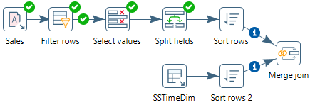

Figure 51: Transformation Design with Steps and Hops to the Merge Join Step

Step 2 – Inner join *SSItem*, *SSCustomer*, and *SSStore* to Access table.

* Inner join the tables named *SSItem*, *SSCustomer*, and *SSStore* in your transformation using the same method described before.
* For *SSItem* step, connect *ItemID* (from Excel file) and *ITEMID* (from Database) fields.
* For *SSCustomer* step, connect *CustID* (from Excel file) and *CUSTID* (from Database) fields.
* For *SSStore* step, connect *StoreID* (from Excel file) and *STOREID* (from Database) fields.
* Figure 52 shows the transformation design for steps and hops to the Merge join 4 step.

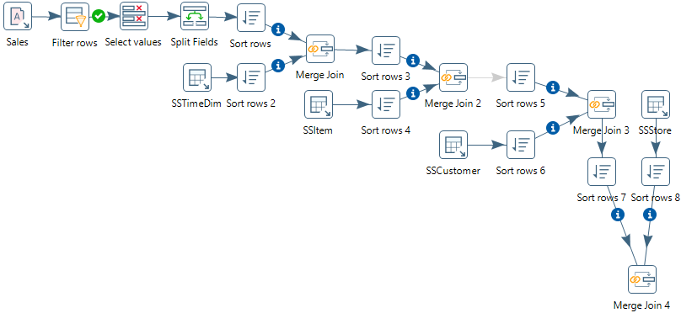

Figure 52: Transformation Design with Steps and Hops to the Merge Join 2 Step

Step 3 – Add SalesNo column.

* Under the **Design** tab, expand the contents of the **Transform** step.
* Click and drag **Add sequence** step into your transformation; create a hop between the **Merge Join 4** and **Add Sequence** steps (Figure 53).
* Double click on the newly created component to open its Basic Settings pane.
* Set **SalesNo** as the name of value. Check the box for use DB to get sequence. Select the **connection** as **PostgreSQL12.2.** Set **SSSalesNoSeq** as sequence name (Figure 54)

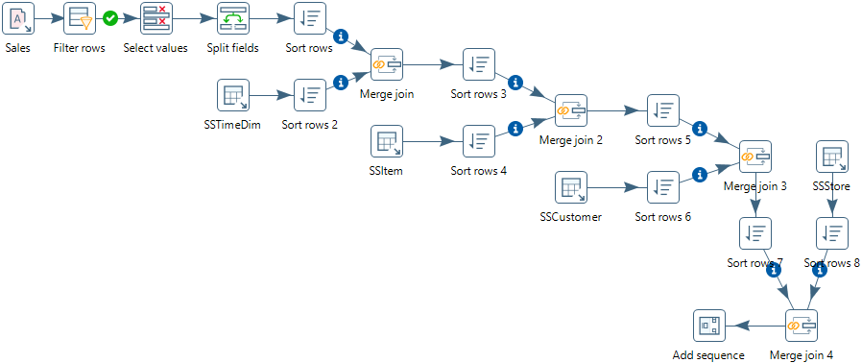

Figure 53: Transformation Design with Steps and Hops to the Add Sequence Step

Figure 54: Property Edit Window of Add sequence step

# 9. Insert rows into the SSSales table

* Under the **Design** tab, expand the contents of the **Output** step.
* Click and drag an **Insert/Update** step into your transformation; create a hop between the **Add sequence** and **Insert/Update** steps. Figure 55 shows the connection in the transformation design pane.
* Double click the **Insert/Update** component, to specify its properties. Set the **step name** as **SSSales**. Select the **connection** as **PostgreSQL12.2**. Type in the **Target table** as **SSSales**. Do not click the “**Get fields**” button. Instead, select SalesNo from the two sources and set the comparator to **=**. Figure 56 shows the window with the lookup values in the middle part.
* Click the button “**Get Updated fields**” and then click on “**Edit mapping**” button to edit mapping. Select the fields named **SalesUnits**, **SalesDollar**, **SaleCost**, **CustID,** **StoreID**, **ItemID** **TIMENO** and **SalesNo** into the **mappings** field. Pentaho will automatically match the corresponding name in the Target field. Only **SalesNo** column must be manually matched with the **SALESNO** field. Then click **OK**. Figure 56 shows the final window.

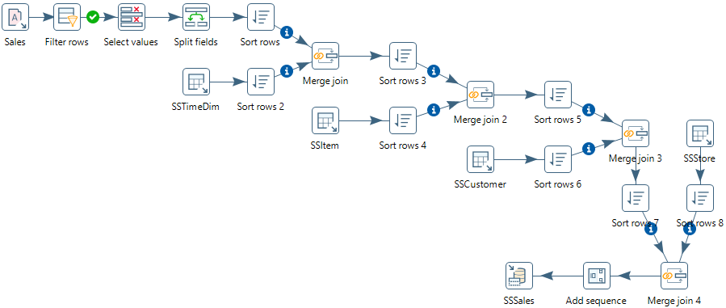

Figure 55: Connect Insert/Update Step to Add Sequence Step

Figure 56: Insert/Update Step Window

* Select the **SSSales** step and run a preview by clicking on . In the transformation debug dialog click on **Quick Launch** button. Figure 57 shows the result rows added to the *SSSales* table after execution of the step. The Step Metrics tab (Figure 58) shows that 8 rows were inserted into the *SSSales* table.
* Connect to your PostgreSQL account (on your PC) so you can verify the number of rows in the *SSSales* table. You should see 208 rows with 8 new rows added to the 200 rows existing after the Excel transformation execution (192 original rows and 8 rows from the Excel transformation).

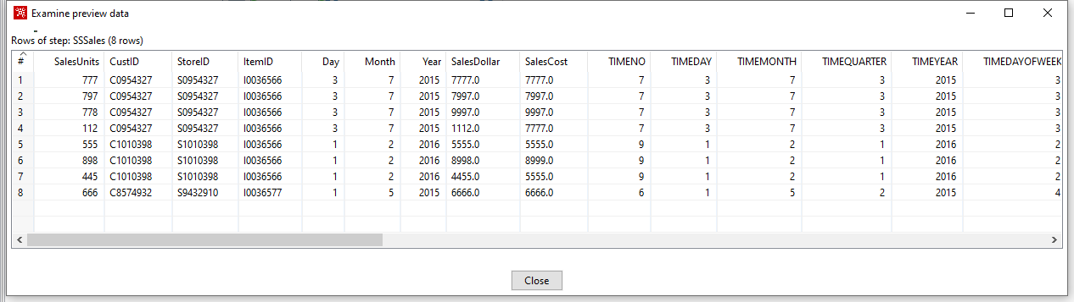

Figure 57: Preview Data for the SSSales Step in the Access Transformation

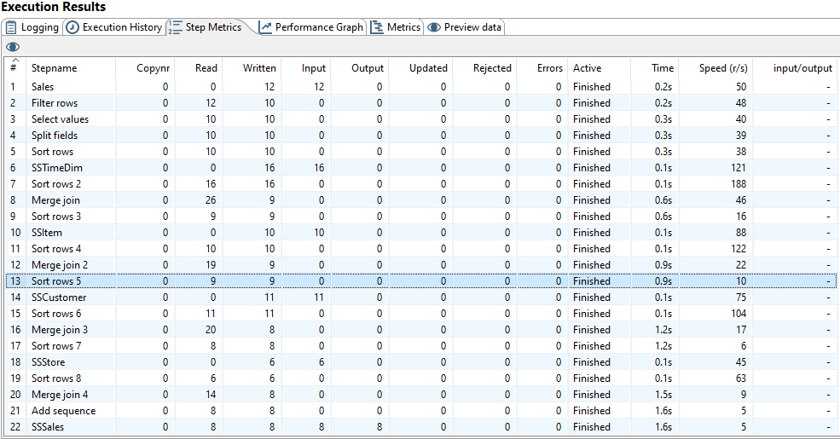

Figure 58: Step Metrics in the Execution Result Window for the Access Transformation